Assessing changes in Population and spatial distribution of Pulvinaria aurantii cockerel in North Country

Abstract
Pulvinaria aurantii is one of the most important pests of citrus trees in the north country.
Changes in population and spatial distribution of citrus pulvinaria aurantii, with using the counting method in spring and summer in the north country was conducted in 2013. The most common methods of sampling this pest is counting. Activity of this pest continue in the second half of may until early october.
The highest average population in nymphs age equal to 2.697 has been observed. To determine the spatial distribution of the indexes Taylor index, Murysta index and index of dispersion is used.
Often in pest the observed cumulative distribution in nymphs, it accumulation gradually reduced.
But the configuration of the cumulative pest dispersion have been preserved in most indicators related to population, not all of them. In indicators mentioned evaluation test were done, and most important cases significant indicator is calculated. The results of this study can be used to manage populations of pulvinaria aurantii.

Key words: Pulvinaria aurantii, population changes, spatial distribution, North Country

Introduction:
Citrus is one of the world's tropical fruit (Reuther,1989 ). Citrus acreage Iran is 222 thousand hectares.Of this Level 90/8% is fertile and 9/2% is seedlings (Bureau of Agricultural Statistics, 2010).
And reduce the amount of pulvinaria aurantii pesticides, in order to manage the population of pulvinaria aurantii much research has been done on the biology and ecology it pest and the role of live and non-live factors in controlling population. Natural enemies as the most important biotic factors plays an important role in pest population dynamic.
One important aspect of animal ecology including insects, its distribution and spatial distribution in nature, which is very useful in ecological studies. So that the distribution of population in addition will affects sampling program type and methods of population data analysis, may also be used for population estimates (Southwood,1995)
Pulvinaria aurantii with honeydew secreted causes the fumazhyn mushrooms to be absorbed and whole surface of leaves, branches and even fruit covers. Biology of Pulvinaria aurantii that in english called; Pulvinaria scale, Pulvinaria arrange and Orange, in Iran and even the world has been studied less. (Jafari, 1993)
Today, the analysis of spatial patterns distribution as one of the important methods of insect population are calculated, and the results of these studies provides basic information for interpret the spatial structure and design of sampling programs to estimate the population and manage them (kuno,1991).
Several factors are effective in shaping the spatial distribution of insects.
That can be cited to oviposition patterns, behavior characteristics, stages
immatures, cumulative pheromone, kayrumun host, hordes host species, the efficiency of natural enemies and non-live factors and host plant quality (pedigo & buntin,1994)
Considering the Pulvinaria aurantii the north country is one of the important pests, use of chemical compounds to control the pests have several disadvantages including; pest resistance, destruction of natural enemies and environmental risks. So by using predators like the two-stain and crypts ladybird and can be used as effective method to help control the pest
patterns of spatial distribution of population in the environment,the most important ecological features its population is considered., and can be studied a gnomon at differentiation between species (taylor,1984).
In the design of sampling programs in order to control or manage pest populations are done, Analysis of distribution element is very important.
(Southwood, 1995). Pulvinaria aurantii in 1927, an important pest of citrus
was introduced in China (Ruther, 1989).
Mentioned species in 1951, a major pest of citrus in Japan, Iran and Russia, was introduced. (Ebeling, 1951)
Studies on pulvinaria aurantii in Iran is low. First time Pulvinaria aurantii with seedlings and cuttings in 1937 came from Russia to Iran.
The first observations were made in 1946 in Rasht and Anzali, but for the following reasons it is not wide dissemination in the region has been mentioned.
1 - Lack of citrus trees, 2 - cold in winter, 3 - existence mushrooms Cepheleosporium Lecanii Zimm (Kryukhyn and Taghizadeh, 1947).
The purpose of this study is knowledge of Pulvinaria aurantii pest changes with regard to climate change and investigate spatial distribution Pulvinaria aurantii .

Materials and Methods:

Abandoned citrus groves was found about 2000 meters and the garden for 5 years that had not been no spraying and to Pulvinaria aurantii pests was polluted.
Trees that infected to Pulvinaria aurantii found and marked. Study the spatial distribution with the sampling 8 days once was performed and 4 infected tree and from each tree 5 leaves randomly selected and a total 20 leaves from even garden were collected and the leaves were transported to the laboratory in plastic bags.
Leaves put under bynukular equipped with a graduated lens and the number of egg bags and the number of instars 1, 2 and 3 were counted.
To determine the spatial distribution of the pest from indices of dispersion were used:Taylor regression, Murysta index, dispersion index

Determining the spatial distribution pattern

1 - Taylor Regression
To determine the spatial distribution of the pest data for each date separately considered, and the logarithm of the variance and their mean ​​were calculated
and from following formula, values ​​of a and b were obtained for each date. (Taylor et al., 1998)
logs² = loga + blogm
m = Data average at each sampling date
S2= the sample variance at each sampling date
B = slope of the regression line
A = confluence of the regression line with the y-axis
If the slope of the regression line is greater than, equal to or smaller than 1
The spatial distribution respectively will be; cumulative, random and uniformly.
To understand from significance of differences b with number 1 the following formula was used:
$$t=\frac{\left|b-1\right|}{{SE}_{b}}$$
t calculated with t table with N-2 degrees of freedom and confidence level of 5% were compared.
If the calculated t is less than t table, therefore accepted the null hypothesis that b = 1 and spatial distribution will be the random, otherwise the, if b> 1 or b <1 ,spatial distribution respectively will be cumulative and uniforms. (Holt et al. 2002),
2 - Murysyta Index
To determine the spatial distribution pattern of mites were used Murysyta index
that its formula is as follows:
$$I_{δ}=\frac{n\sum{x_{i}(x_{i}-1)}}{N(N-1)}$$

n = number of samples
Xi = number of individuals in sample i
N = overall number of individuals In the all samples
If Murysyta index, respectively greater than 1, equal to 1 or smaller than 1
Spatial distribution type will be cumulative, random and uniformly.
From Z test According to following equation (Pedigo & Buntin, 1994) Were used to understand the significant difference between the I and the number 1.

$$Z=\frac{(I_{δ}-1)}{{(\frac{2}{{nm}^{2}})}^{\frac{1}{2}}}$$
In the above formula, n = number of samples and m is the data average. If the calculated value of Z is greater than 1/96 , Spatial distribution type will be cumulative, between 1/96 and -1/96, random and smaller than the -1/96 will be uniform.This method for all dates the sampling separately calculated (Morisita, 1959).
3 - Distribution Index
Distribution of ID, is one of the oldest and simplest method of determining the distribution of organisms and according to many scientists, is an ideal method
(Morisita, 1959)
In this method all different sampling data was used together according to the following formula:
$$I_{D}=X^{2}= \frac{S^{2}(n-1)}{m}$$
D =Dispersion index
S2 = variance data
m = Data average.
If the number of samples is large The following equation is used:
$$Z=\sqrt{2X^{2}}-\sqrt{2(υ-1)}$$
χ2= observed K square
υ = degrees of freedom (n-1)
If the numerical value of the parameter Z is between 1/ 96 and -1/ 96, As a result, the null hypothesis that the data follow from random distribution is confirmed.
Otherwise, if I <1 or I> 1, the spatial distribution will be respectively
cumulative and uniform. (Greco et al., 1999)

Table 1: Average population in Pulvinaria aurantii in date of sampling :
Nymph 3 Age | Nymph 2 Age | Nymph 1 Age | Egg Bag
0 | 0 | 7 | 2/85 | 92/3/16
0 | 0 | 2/85 | 1/45 | 92/3/23
0 | 0 | 1/45 | 1.6 | 92/3/30
0 | 0 | 6/4 | 0/65 | 92/4/7
0 | 0 | 3/65 | 0/4 | 92/4/15
0/15 | 0/15 | 1/4 | 0.1 | 92/4/23
0/05 | 0 | 0 | 0/2 | 92/4/31
0/05 | 0/1 | 0/55 | 0.05 | 92/5/8
0 | 0/1 | 1/6 | 0.25 | 92/5/16

Interaction of pests and their natural enemies toward live and non-live factors in the environment of causes the recognize the importance of habitat in diversity and abundance of organisms and their spatial distribution can hardly be possible. (Coll & Bottrell, 1995)
Observations (Aulah, 1995) indicate that the population of nymphal instars and
adult insects pulvinaria maxima green in Bangladesh in june has high density.
Studies (Sngvnka, 1996) indicated a peak adult pulvinaria regalis kanard is in early may and the peaks of the first, second and third instars respectively is in the early july, late august and late aktbrast.
Observations (HallajSani, 1999) indicates the peak of egg bags is from 26 may to 8 june in nature.Their density is very high on 20 june. Egg bags on the lower parts of the trees, especially the outer surface has a greater density.

Table 2. Indicator of the spatial distribution of egg bags
values | Index
1/14 | B
2/37 | ID
2/63 | Iδ

(Hsu, et al, 2001) the oyster spatial distribution pattern aulacaspis abunikkei (Hom. Diaspididae)
By using Taylor regression have examined. The results showed that the spatial distribution pattern of the insect's life stages are cumulative. So that the Taylor Index is significantly more than 1.
Interaction pests and their natural enemies toward live and non-live factors in the environment causes that recognize the importance of habitat in diversity and abundance of organisms and also their spatial distribution is hardly possible (Coll & Bottrell, 1995).
The coefficient b is greater than 1.Thus the spatial distribution of the pest is cumulative.
Distribution index in sampleing spatial determines that the distribution of pest is cumulative.
Based on the formula (N-1) (S2/mean) its numerical value is 434.
Therefore, the calculated index is significantly, because it is larger than k-square table. Results of Murysta index shows the distribution space is cumulative. calculated Z is greater than 1/ 96.
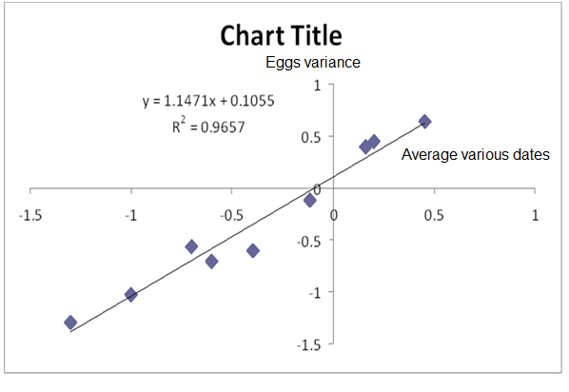
Graph of Taylor linear equation in sampling egg bag

Table 3. Indicator of the spatial distribution age nymph 1
values | Index
1/071 | B
7/75 | ID
3/51 | Iδ

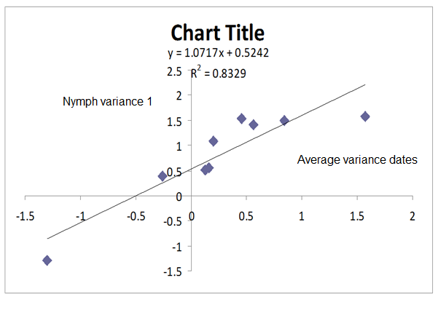Graph of Taylor linear equation in sampling age nymph 1

(HallajSani, 1999), sampling from 30cm canopy of citrus trees, also the around trees and count pulvinaria aurantii nymphs revealed that the spatial distribution of the trees are accumulative.
The spatial distribution (b) for canopy trees was calculated 1/35 and for leaves around the crown 1/59.The b coefficient is greater than 1. Thus the spatial distribution of the pest is a cumulative
Taylor index test show that it is consistent with the cumulative distribution. Calculated distribution index is the cumulative. Based on the formula (N-1) (S2/mean) its numerical value is 1387 and greater than the k-square table and confirm the significance of the calculated index. Murysta index confirms that type of pest is cumulative.

Table 4. Indicator of the spatial distribution age nymph 2
values | index
1/03 | B
146 | ID
49/76 | Iδ

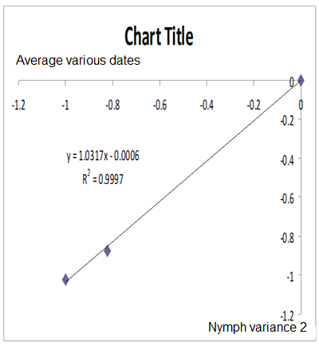
Graph of Taylor linear equation in sampling age nymph 2

The spatial distribution of a pest or natural enemy to be better known in the same population size is measured in natural ecosystems easier (Radjabi, 2003 .(
here b is greater than 1, so that distribution is cumulative. In Taylor index test considering that calculated t higher than from T table; t-Student shows its alignment with the cumulative distribution. In distribution index the spatial distribution of in pest is cumulative.
And confirm the significance of the calculated index also spatial distribution of pest in Murysta index is cumulative.

Table 5. Indicator of the spatial distribution age nymph 3
values | index
0/47 | B
174/88 | ID
52/32 | Iδ

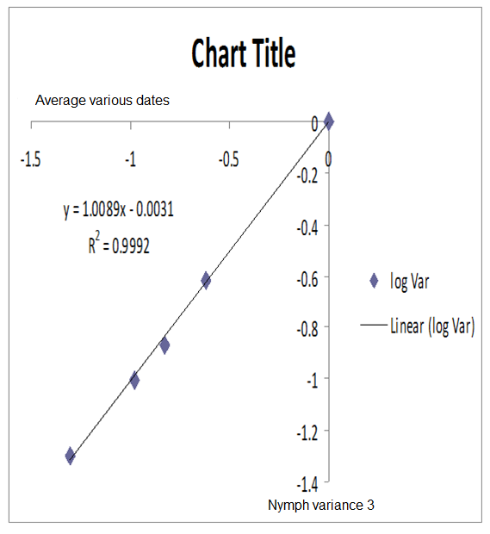
Graph of Taylor linear equation in sampling age nymph 3
Spatial distribution of crab louse covered flour the branches is determined 1/61. The spatial distribution of trees in this area are accumulative. (Nestel, et al, 1995).
Obtained coefficient b shows the spatial distribution of contingency. Sampling Distribution index shows cumulative spatial distribution and shows the calculated index is significant. Murysta index represents the cumulative distribution.

